# 实验2：三层交换

**三层交换的目的：实现不同vlan之间互相访问**

**SW1(config)#ip routing //开启路由功能**

**SW1(config)#interface g0/0**

**SW1(config-if)#no switchport //关闭交换机接口，才能在三层交换机接口上设置IP地址**

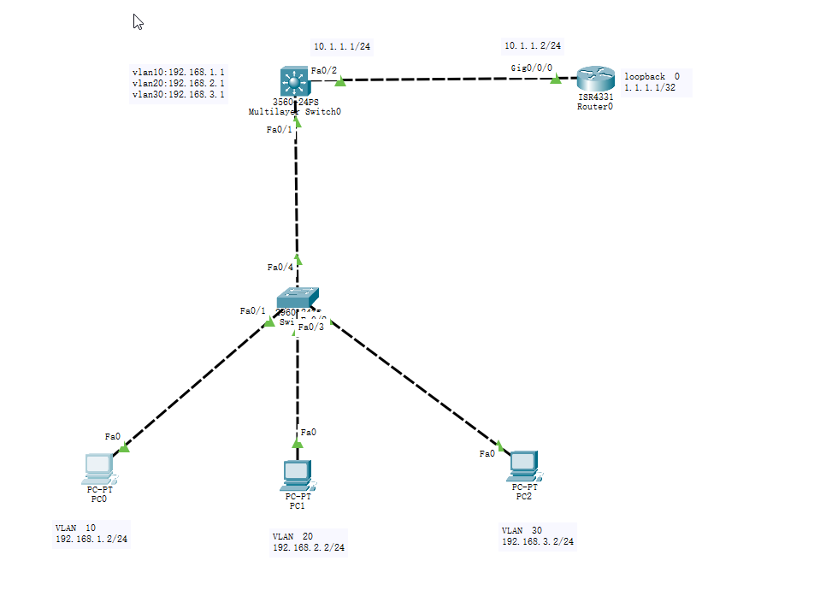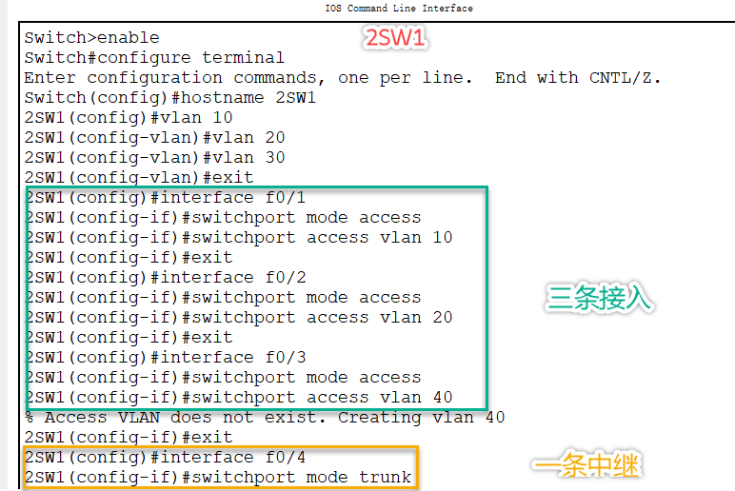

**3SW1：**

**Enable 特权模式**

**Configure terminal 全局模式**

**Hostname 3SW1 重命名**

**Ip routing 开启路由功能**

**Vlan 10 创建vlan10**

**Vlan 20 创建vlan20**

**Vlan 30 创建vlan30**

**Exit 退出**

**Interface f0/1 进入f0/1接口**

**Switchport trunk encapsulation dot1q 交换机端口封装成802.1q**

**Switchport mode trunk 交换机端口模式为中继**

**Exit 退出**

**Interface vlan 10 进入vlan10虚接口**

**Ip address 192.168.1.1 255.255.255.0 设置虚接口IP**

**No shutdown 激活端口**

**Exit 退出**

**Interface vlan 20 进入vlan20虚接口**

**Ip address 192.168.2.1 255.255.255.0 设置虚接口IP**

**No shutdown 激活端口**

**Exit 退出**

**Interface vlan 30 进入vlan30虚接口**

**Ip address 192.168.3.1 255.255.255.0 设置接口IP**

**No shutdown 激活端口**

**Exit 退出**

**Interface f0/2 进入f0/2接口**

**No swichport 关闭交换机端口**

**Ip address 10.1.1.1 255.255.255.0 设置端口IP**

**No shutdown 激活路由端口**

**Ip route 0.0.0.0 0.0.0.0 10.1.1.2 静态路由指向路由器回环地址R1:**

**Interface g0/0/0 进入g0/0/0接口**

**Ip address 10.1.1.2 255.255.255.0 设置接口IP**

**No shutdown 激活端口**

**Exit 退出**

**Interface loopback 0 进入loopback0**

**Ip address 1.1.1.1 255.255.255.255 设置IP**

**No shutdown 激活端口**

**Exit**

**Ip route 192.168.1.0 255.255.255.0 10.1.1.1 三条静态路由**

**Ip route 192.168.2.0 255.255.255.0 10.1.1.1 分别指向三个vlan**

**Ip route 192.168.3.0 255.255.255.0 10.1.1.1**

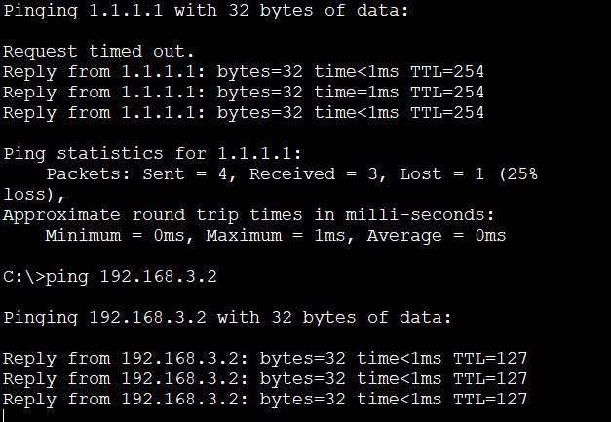

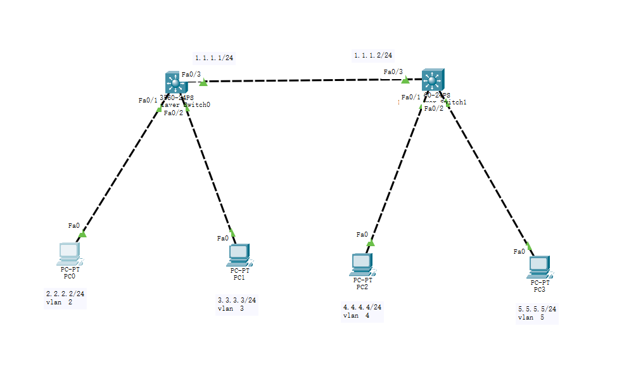

**3SW1：**

**Enable 特权模式**

**Configure terminal 全局模式**

**Hostname 3SW1 重命名**

**Vlan 2 创建vlan2**

**Vlan 3 创建vlan3**

**Exit 退出**

**Ip routing 开启路由功能**

**Interface f0/1 进入f0/1接口**

**Switchport mode access 交换机端口模式为接入**

**Switchport access vlan 2 交换机端口接入vlan2**

**Exit 退出**

**Interface f0/2 进入f0/2**

**Switchport mode access 交换机端口模式为接入**

**Switchport access vlan 3 交换机端口接入vlan3**

**Exit 退出**

**Interface vlan 2 进入vlan2虚接口**

**Ip address 2.2.2.1 255.255.255.0 设置接口IP**

**No shutdown 激活端口**

**Exit 退出**

**Interface vlan 3 进入vlan3虚接口**

**Ip address 3.3.3.1 255.255.255.0 设置接口IP**

**No shutdown 激活端口**

**Exit 退出**

**Interface f0/3 进入f0/3接口**

**No switchport 关闭交换机端口**

**Ip address 1.1.1.1 255.255.255.0 设置接口IP**

**No shutdown 激活端口**

**Exit**

**Ip route 4.4.4.0 255.255.255.0 1.1.1.2 两条静态路由指向vlan4和vlan5**

**Ip route 5.5.5.0 255.255.255.0 1.1.1.2**

# 实验3：DHCP中继代理

**DHCP中继代理作业：DHCP服务器通过三层交换机的DHCP中继代理分发不同网段的IP地址**

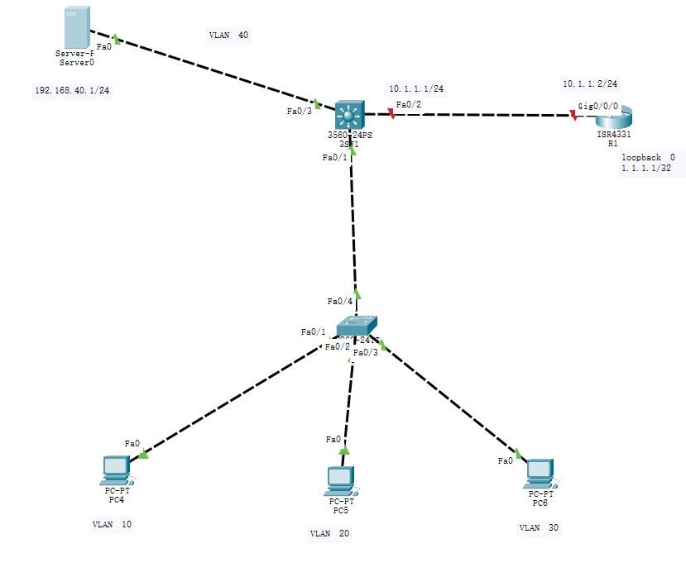

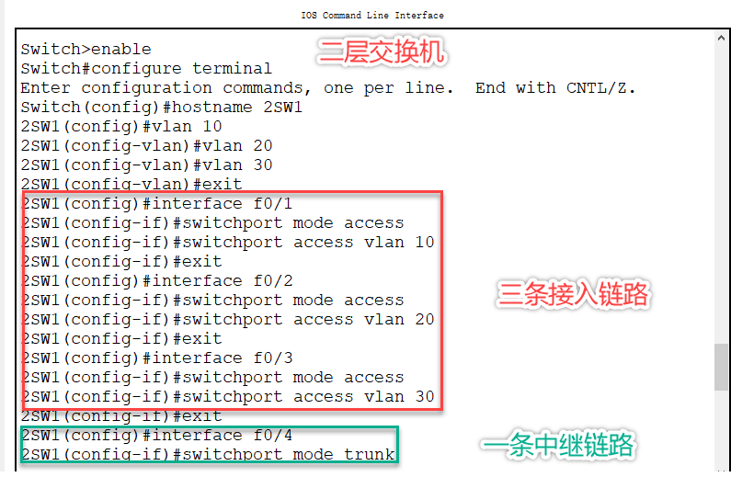

**3SW1：**

**Enable**

**Configure terminal**

**Hostname 3SW1**

**Vlan 10 创建vlan10**

**Vlan 20 创建vlan20**

**Vlan 30 创建vlan30**

**Vlan 40 创建vlan40**

**Exit**

**Ip routing 开启路由功能**

**Interface f0/1**

**Switchport trunk encapsulation dot1q 交换机端口封装成802.1q**

**Switchport mode trunk 交换机端口模式为中继**

**Exit**

**Interface f0/3**

**Switchport mode access**

**Switchport access vlan 40**

**Exit**

**Interface vlan 10**

**Ip address 192.168.10.254 255.255.255.0**

**Ip helper-address 192.168.40.1 设置DHCP中继代理地址是服务器的IP**

**No shutdown**

**Exit**

**Interface vlan 20**

**Ip address 192.168.20.254 255.255.255.0**

**Ip helper-address 192.168.40.1**

**No shutdown**

**Exit**

**Interface vlan 30**

**Ip address 192.168.30.254 255.255.255.0**

**Ip helper-address 192.168.40.1**

**No shutdown**

**Exit**

**Interface f0/2**

**No switchport**

**Ip address 10.1.1.1 255.255.255.0**

**No shutdown**

**Ip route 0.0.0.0 0.0.0.0 10.1.1.2**

**R1:**

**Ip route 192.168.10.0 255.255.255.0 10.1.1.1**

**Ip route 192.168.20.0 255.255.255.0 10.1.1.1**

**Ip route 192.168.30.0 255.255.255.0 10.1.1.1**

